<Project Name>

System Design

<Version>

<Date>

<Your Name>

Prepared for

SE301 Software Engineering



Table of Contents

1. Introduction 1

1.1. Purpose of the System 1

1.2. Design Goals 1

1.3. Definitions, Acronyms, and Abbreviations 1

1.4. References 1

2. Current Software Architecture 1

3. Proposed Software Architecture 1

3.1. Overview 1

3.2. System Decomposition 1

3.3. Hardware Software Mapping 2

3.4. Persistent Data Management 2

3.5. Access Control and Security 2

3.6. Global Software Control 2

3.7. Boundary Conditions 2

4. Subsystem Services 2

5. References 2

SYSTEM DESIGN DOCUMENT[1]

The System Design Document (SDD) is written after the initial system decomposition is done, and updated throughout the development. SDD describes the services provided by each subsystem. Although this section is usually empty or incomplete in the first versions of the SDD, this section serves as a reference for teams for the boundaries between their subsystems. The interface of each subsystem is derived from this section and detailed in the Object Design Document.

SDD is used to define interfaces between teams of developers and serve as a reference when architecture-level decisions need to be revisited. The audience for the SDD includes the project management, the system architects (i.e., the developers who participate in the system design), and the developers who design and implement each subsystem.

# Introduction

Provide a brief overview of the software architecture and the design goals. It also provides references to other documents and traceability information (e.g., related requirements analysis document, references to existing systems, constraints impacting the software architecture).

## Purpose of the System

## Design Goals

## Definitions, Acronyms, and Abbreviations

## References

References to existing systems, etc.

# Current Software Architecture

Describe the architecture of the system being replaced**. If there is no previous system**, this section can be replaced by **a survey of current architectures for similar systems**. The purpose of this section is to make explicit the background information that system architects used, their assumptions, and common issues the new system will address.

# Proposed Software Architecture

Documents the system design model of the new system.

## Overview

The system will have a 3-layer design approach in its architecture. These 3 layers will be the Interface which will allow its users to interact with the system, the Application, which is the functionality of the system itself and the Storage layer where all the persistent data is kept.

Storage layer holds the UserData, DonationData and CampaignData subsystems. UserData holds the required information about the system’s users: Donators, NGOs, and the Admin. DonationData holds the data for each donation, monetary or item. CampaignData holds the data about Campaigns: their donation type, title, information text, etc.

Application layer holds the User, Campaign, Donation and Administration subsystems. User subsystem holds the registration and profile editing functions and is further divided into two: Donator and NGO subsystems. The Donator subsystem holds donator user-specific functions such as retrieving personal donations and viewing pending item donations etc. NGO subsystem is for the NGO-specific functions, viewing received donations, campaigns, profile page editing etc. Campaign subsystem is about creating and editing a campaign. Donation subsystem is for donations and divides into two subsystems, MonetaryDonation and ItemDonation. MonetaryDonation holds procedure for donating money for NGO’s or their campaigns. ItemDonation is for donating items for campaigns and also holds the Delivery subsystem which is responsible for generating free shipping codes and accepting shipping tracking codes. Finally, Administration subsystem holds the functions for the Admin which are accepting (or rejecting) new user registrations, receiving and sending messages from/to users and managing all users, campaigns and donations.

The Interface layer, as our system will be a website, will hold the webpages for the system through which the users will interact. It holds a ‘View’ subsystem for each Application layer subsystem and also holds the Navigation subsystem which holds pages like the homepage and the site’s search function.

## System Decomposition

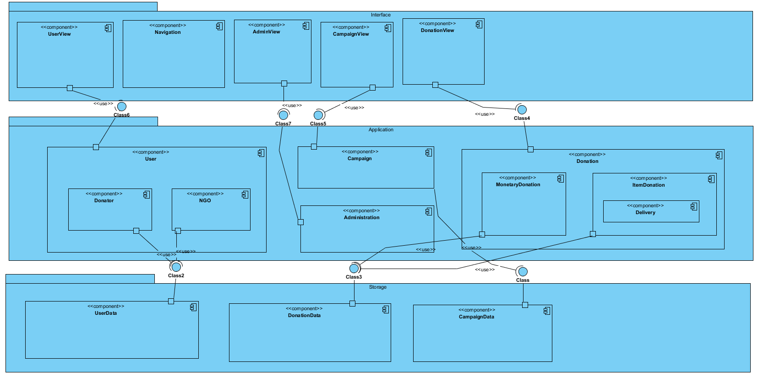

## Hardware Software Mapping

Describe how subsystems are assigned to hardware and off-the-shelf components. It also lists the issues introduced by multiple nodes and software reuse.

## Persistent Data Management

Describe the persistent data stored by the system and the data management infrastructure required for it. This section typically includes the description of **data schemes, the selection of a database, and the description of the encapsulation of the database**.

## Access Control and Security

Describe the user model of the system in terms of an access matrix. This section also describes security issues, such as the selection of an authentication mechanism, the use of encryption, and the management of keys.

## Global Software Control

Describe how the global software control is implemented. In particular, this section should describe how requests are initiated and how subsystems synchronize. This section should list and address synchronization and concurrency issues.

## Boundary Conditions

Describe the start-up, shutdown, and error behavior of the system. (If new use cases are discovered for system administration, these should be included in the requirements analysis document, not in this section.)

# Subsystem Services

Describe the **services provided by each subsystem**. Although this section is usually empty or incomplete in the first versions of the SDD, this section serves as a reference for teams for the boundaries between their subsystems. The interface of each subsystem is derived from this section and detailed in the Object Design Document.

# References

The following is an example of listing a book in this section. Check the text to see how it is cross referenced (The whole document is based on [1]).

1. Bruegge B. & Dutoit A.H.. (2010). *Object-Oriented Software Engineering Using UML, Patterns, and Java*, Prentice Hall, 3rd ed.